**TOUR AND TRAVEL**

**A PROJECT REPORT**

**for**

**Mini Project (KCA353)**

**Session (2023-24)**

**Submitted by**

**TRIPTI SHRIVASTAVA**

**(University Roll No. 2200290140160)**

**Submitted in partial fulfillment of the**

**Requirements for the Degree of**

**MASTER OF COMPUTER APPLICATION**

**Under the Supervision of**

**Dr. SANGEETA ARORA**

(ASSOCIATE PROFESSOR)



**Submitted to**

**Department Of Computer Applications**

**KIET Group of Institutions, Ghaziabad**

**Uttar Pradesh-201206**

**(JANUARY -2024)**

**CERTIFICATE**

Certified that **TRIPTI SHRIVASTAVA (2200290140160)** has carried out the project work having “**TOUR AND TRAVEL**” (**Mini Project-KCA353**) for **Master of Computer Application** from Dr. A.P.J. Abdul Kalam Technical University (AKTU**)** (formerly UPTU), Lucknow under my supervision. The project report embodies original work, and studies are carried out by the student herself and the contents of the project report do not form the basis for the award of any other degree to the candidate or to anybody else from this or any other University/Institution.

**Date: 01-JAN-2024**

**TRIPTI SHRIVASTAVA (2200290140160)**

This is to certify that the above statement made by the candidate is correct to the best of my knowledge.

**Date: 01-JAN-2024**

**Dr. SANGEETA ARORA Dr. ARUN TRIPATHI**

**Assistant Professor Head**

**Department of Computer Applications Department of Computer Applications**

**KIET Group of Institutions, Ghaziabad KIET Group of Institutions, Ghaziabad**

**ABSTRACT**

A Tour and Travel System website serves as a comprehensive platform designed to facilitate the planning, booking, and management of travel experiences. It typically offers a user-friendly interface that allows visitors to explore various destinations, browse through available tour packages, and make reservations for flights, accommodations, and activities. The website often incorporates features such as real-time availability, secure payment gateways, and detailed information on travel itineraries. Additionally, users may find reviews, ratings, and recommendations to assist in decision-making. The Tour and Travel System website aims to streamline the entire travel process, providing a one-stop solution for individuals seeking convenient and efficient trip planning.

The objective of the project is to develop a system that automates the processes and activities of a travel and. The purpose is to design a system using which one can perform all operations related to traveling.Top of Form

**ACKNOWLEDGEMENT**

Success in life is never attained single-handedly. My deepest gratitude goes to my project supervisor, **Dr. Sangeeta Arora** for her guidance, help, and encouragement throughout my project work. Their enlightening ideas, comments, and suggestions.

Words are not enough to express my gratitude to Dr. Arun Kumar Tripathi, Professor and Head, Department of Computer Applications, for his insightful comments and administrative help on various occasions.

Fortunately, I have many understanding friends, who have helped me a lot on many critical conditions.

Finally, my sincere thanks go to my family members and all those who have directly and indirectly provided me with moral support and other kind of help. Without their support, completion of this work would not have been possible in time. They keep my life filled with enjoyment and happiness.

**TRIPTI SHRIVASTAVA**

**CHAPTER- 1**

**INTRODUCTION**

Tour & Travel is an irresistible word when it comes to tour and travel packages. We offer tour and travel services including ticket bookings, hotel reservations, rental car services, holiday tour packages, domestic tour packages. We provide the most suitably designed as well as the customized travel packages to the customers. We offer everything related to travelling services under one roof.

Today's extremely exhausting work environment dictates that individuals requires some joyful holiday. We provide stress-free joyful refreshing holidays with cost competitive and customized packages according to their requirements. We provide services in almost each and every city of India. We want to serve our customers with best possible service and provide them the kind of comfort they want.

**CHAPTER -1.1**

**SCOPE OF PROJECT**

The Website is developed based on real life. It is very helpful in business applications. Today's extremely exhausting work environment dictates that individuals requires some joyful holiday. The website will provides a stress-free joyful refreshing holidays with cost competitive and customized packages according to their requirements.As it is web based it can provide services in almost each and every city of India. It offer tour and travel services including ticket bookings, hotel reservations,rental car services, holiday tour packages, domestic tour packages only in one click. It provide the most suitably designed as well as the customized travel packages to the customers. A traveler can find everything related to travelling services under one roof by this website. The site will help to estimate the benefits and calculate the requirement very easily. The benefits will be in terms of speedy query .Smooth and faster operations at all levels improve the working atmosphere of the entire organization. Maintaining the database as required. Database can be modified accordingly.

**CHAPTER – 1.2**

**MODULES**

In a Tour and Travel System project, there are typically two main modules: the Admin Module and the User Module. Each module serves distinct roles and functionalities to ensure the smooth functioning of the system.

**Admin Module:**

1 **.Dashboard**

2- **View Personal Details**

3- **View Package**

4**- View Book Hotel Details**

5- **Customer Support**

**User Module:**

1- **Signup and Login**

2- **Browsing and Searching**

3- **Booking and Reservation**

4- **Payment and Checkout**

5- **Profile Management**

**CHAPTE- 1.3**

**BENEFITS OF TOUR AND TRAVEL**

**For Users**

1. Convenience

2. Comprehensive Information

3. Real-Time Availability

4. Customization Options

5. Secure Transactions

6. Reviews and Ratings

7. Time Efficiency

8. Notifications and Ale

**For Business**

1. Increased Reach
2. Operational Efficiency
3. Collaboration Opportunities
4. Marketing and Promotion
5. Customer Relationship Management (CRM)
6. Data Analytics
7. Brand Visibility
8. Financial Management

**CHAPTER-1.5**

**FUTURE LOOK**

The future of Tour and Travel System projects envisions a technologically advanced and user-centric landscape, where innovations will revolutionize the way individuals plan and experience their journeys. Artificial Intelligence (AI) is expected to play a crucial role, with AI-powered chatbots providing personalized customer support and algorithms delivering intelligent recommendations for customized travel itineraries. Virtual Reality (VR) and Augmented Reality (AR) will likely become integral components, offering immersive experiences for users to preview destinations and accommodations through virtual tours. Blockchain technology is anticipated to enhance security, enabling transparent and secure financial transactions with the integration of smart contracts for automated booking processes.

**CHAPTER-1.6**

**CONCLUSION**

In conclusion, a Tour and Travel Project represents a dynamic and essential component of the evolving travel industry, adapting to technological advancements and changing consumer preferences. The project's primary goal is to provide users with a seamless and enjoyable travel experience by leveraging innovative solutions. Features such as real-time availability, customization options, secure transactions, and comprehensive information contribute to the convenience and satisfaction of users.

For businesses within the travel industry, the project facilitates operational efficiency through tools for booking management, collaboration with service providers, and marketing strategies. The integration of technologies like artificial intelligence, virtual reality, and blockchain enhances the project's capabilities, offering personalized recommendations, immersive previews, and secure financial transactions.

Looking ahead, the future of Tour and Travel Projects holds exciting possibilities, with trends such as sustainable travel initiatives, IoT connectivity, and advanced analytics shaping the landscape. The increasing focus on user-centric design, mobile accessibility, and personalized marketing underscores the industry's commitment to meeting the diverse needs of modern travelers.

In essence, a well-executed Tour and Travel Project not only streamlines the planning and booking processes but also contributes to creating memorable and fulfilling travel experiences. As the travel industry continues to evolve, these projects are poised to play a pivotal role in meeting the demands of an increasingly connected and discerning global audience.

**CHAPTER_2**

**ER DIAGRAM**

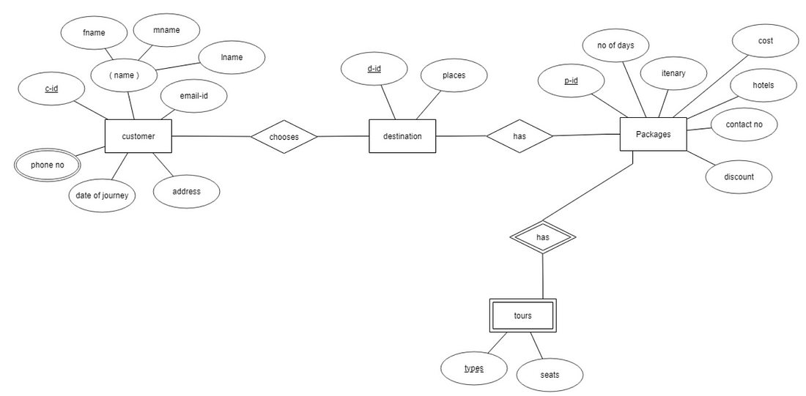

**CHAPTER-2.1**

**DFD**

Add

Travels

Travel Master

View

Delete

**SOURCE CODE**

**AdminLogin.java**

package TourAndTravel;

import java.awt.*;

import javax.swing.*;

import javax.swing.border.*;

import java.awt.event.*;

public class AdminHome extends JFrame implements ActionListener {

public JPanel contentPane;

public JPanel profilepanel;

private final Color buttonbcolor = Color.DARK_GRAY;

private final Color buttonfcolor = Color.LIGHT_GRAY;

private final Font buttonfont = new Font("Tw Cen MT", Font.PLAIN, 20);

JButton b1, b2, b3, b4, b5, b6, b7, b8, btn;

public int panely = 0, panelx = 250, row = 0;

public HomePanel homepanel;

public ProfilePanel yourprofile;

public PackagePanel packagepanel;

public HotelPanel hotelpanel;

public AllCustomerPanel allcustomerpanel;

public BookedPackagePanel bookedpackagepanel;

public BookedHotelPanel bookedhotelpanel;

String username;

public static void main(String[] args) {

new AdminHome("").setVisible(true);

}

AdminHome(String username) {

super("AdminHome");

this.username = username;

setExtendedState(JFrame.MAXIMIZED_BOTH);

setDefaultCloseOperation(JFrame.EXIT_ON_CLOSE);

contentPane = new JPanel();

contentPane.setBackground(Color.WHITE);

setContentPane(contentPane);

contentPane.setLayout(null);

profilepanel = new JPanel();

profilepanel.setBounds(5, 7, 240, 63);

contentPane.add(profilepanel);

profilepanel.setBackground(Color.DARK_GRAY);

profilepanel.setLayout(null);

JLabel l1 = new JLabel("Administrator");

l1.setForeground(Color.WHITE);

l1.setFont(new Font("Tw Cen MT", Font.BOLD, 25));

l1.setBackground(Color.DARK_GRAY);

l1.setHorizontalAlignment(SwingConstants.CENTER);

l1.setBounds(0, 14, 240, 36);

profilepanel.add(l1);

createHomepanel();

JPanel sidebarpanel = new JPanel();

sidebarpanel.setBackground(Color.DARK_GRAY);

sidebarpanel.setBounds(5, 75, 240, 714);

contentPane.add(sidebarpanel);

sidebarpanel.setLayout(null);

b1 = createButton("Home");

sidebarpanel.add(b1);

btn = b1;

b2 = createButton("Your Profile");

sidebarpanel.add(b2);

b3 = createButton("Package");

sidebarpanel.add(b3);

b4 = createButton("Hotel");

sidebarpanel.add(b4);

b5 = createButton("All Customer");

sidebarpanel.add(b5);

b6 = createButton("Booked Package");

sidebarpanel.add(b6);

b7 = createButton("Booked hotel");

sidebarpanel.add(b7);

b8 = createButton("LogOut");

sidebarpanel.add(b8);

activeButton(b1);

homepanel.setVisible(true);

}

public void createHomepanel() {

homepanel = new HomePanel(this);

homepanel.setLocation(panelx, panely);

homepanel.setFocusable(true);

contentPane.add(homepanel);

}

public void activeButton(JButton button) {

btn.setBackground(buttonbcolor);

btn.setForeground(buttonfcolor);

btn.setFont(buttonfont);

btn = button;

btn.setForeground(Color.WHITE);

btn.setFont(new Font("Tw Cen MT", Font.BOLD, 23));

disablePanel();

}

public JButton createButton(String text) {

JButton button = new JButton(text);

button.setForeground(buttonfcolor);

button.setFont(buttonfont);

button.setBackground(buttonbcolor);

button.setHorizontalAlignment(SwingConstants.LEFT);

button.setFocusable(false);

button.setCursor(new Cursor(Cursor.HAND_CURSOR));

button.setBorder(new EmptyBorder(0, 0, 0, 0));

button.addActionListener(this);

button.setLocation(0, row);

button.setSize(234, 40);

row += 40;

return button;

}

public void disablePanel() {

if (homepanel != null && homepanel.isVisible()) {

homepanel.setVisible(false);

} else if (packagepanel != null && packagepanel.isVisible()) {

packagepanel.setVisible(false);

} else if (yourprofile != null && yourprofile.isVisible()) {

yourprofile.setVisible(false);

} else if (hotelpanel != null && hotelpanel.isVisible()) {

hotelpanel.setVisible(false);

}

else if(allcustomerpanel!=null && allcustomerpanel.isVisible())

{

allcustomerpanel.setVisible(false);

}

else if(bookedpackagepanel!=null && bookedpackagepanel.isVisible())

{

bookedpackagepanel.setVisible(false);

}

else if(bookedhotelpanel!=null && bookedhotelpanel.isVisible())

{

bookedhotelpanel.setVisible(false);

}

}

@Override

public void actionPerformed(ActionEvent e) {

openPanel(e.getSource());

}

public void openPanel(Object source) {

if (source == b1) {

activeButton(b1);

homepanel = new HomePanel(this);

homepanel.setLocation(panelx, panely);

homepanel.setFocusable(true);

contentPane.add(homepanel);

} else if (source == b2) {

activeButton(b2);

yourprofile = new ProfilePanel(this, username);

yourprofile.setLocation(panelx, panely);

yourprofile.setFocusable(true);

contentPane.add(yourprofile);

} else if (source == b3) {

activeButton(b3);

packagepanel = new PackagePanel(this);

packagepanel.setLocation(panelx, panely);

packagepanel.setFocusable(true);

contentPane.add(packagepanel);

} else if (source == b4) {

activeButton(b4);

hotelpanel = new HotelPanel(this);

hotelpanel.setLocation(panelx, panely);

hotelpanel.setFocusable(true);

contentPane.add(hotelpanel);

} else if (source == b5) {

activeButton(b5);

allcustomerpanel = new AllCustomerPanel();

allcustomerpanel.setLocation(panelx, panely);

allcustomerpanel.setFocusable(true);

contentPane.add(allcustomerpanel);

} else if (source == b6) {

activeButton(b6);

bookedpackagepanel = new BookedPackagePanel();

bookedpackagepanel.setLocation(panelx, panely);

bookedpackagepanel.setFocusable(true);

contentPane.add(bookedpackagepanel);

} else if (source == b7) {

activeButton(b7);

bookedhotelpanel = new BookedHotelPanel();

bookedhotelpanel.setLocation(panelx, panely);

bookedhotelpanel.setFocusable(true);

contentPane.add(bookedhotelpanel);

} else if (source == b8) {

activeButton(b8);

this.dispose();

new Home().setVisible(true);

}

}

}

**Login.java**

package TourAndTravel;

import java.awt.*;

import javax.swing.*;

import java.awt.event.*;

import java.sql.*;

public class Login extends JPanel implements ActionListener{

JPanel p1, p2;

JTextField t1;

JPasswordField passwordField;

JButton b1, b2, b3;

Home home;

JLabel l5;

Login() {

setSize(1540,800);

setBackground(Color.WHITE);

setLayout(null);

p1 = new JPanel();

p1.setBackground(new Color(255, 255, 233));

p1.setBounds(440, 230, 360, 273);

p1.setLayout(null);

add(p1);

p2 = new JPanel();

p2.setBounds(800, 200, 400, 300);

p2.setBackground(Color.WHITE);

p2.setLayout(null);

add(p2);

JLabel l1 = new JLabel("Username ");

l1.setBounds(30, 20, 100, 25);

l1.setFont(new Font("SAN_SERIF", Font.BOLD, 15));

p1.add(l1);

JLabel l2 = new JLabel("Password ");

l2.setBounds(30, 90, 100, 25);

l2.setFont(new Font("SAN_SERIF", Font.BOLD, 15));

p1.add(l2);

t1 = new JTextField();

t1.setBounds(30, 55, 280, 25);

t1.setBorder(BorderFactory.createEmptyBorder());

p1.add(t1);

passwordField = new JPasswordField();

passwordField.setBounds(30, 125, 280, 25);

passwordField.setBorder(BorderFactory.createEmptyBorder());

p1.add(passwordField);

ImageIcon i1 = new ImageIcon(ClassLoader.getSystemResource("Travel/Management/System/icons/login.jpg"));

Image i2 = i1.getImage().getScaledInstance(300, 300,Image.SCALE_DEFAULT);

ImageIcon i3 = new ImageIcon(i2);

JLabel l3 = new JLabel(i3);

l3.setBounds(0, 20, 300, 300);

p2.add(l3);

l5 = new JLabel("LOGIN");

l5.setBounds(680, 160, 400, 50);

l5.setFont(new Font("TIMES NEW ROMAN", Font.PLAIN, 40));

l5.setForeground(new Color(205, 92, 92));

l5.setBackground(Color.WHITE);

add(l5);

b1 = new JButton("Login");

b1.addActionListener(this);

b1.setForeground(new Color(46, 139, 87));

b1.setBackground(new Color(176, 224, 230));

b1.setBounds(30, 175, 120, 25);

p1.add(b1);

b2 = new JButton("SignUp");

b2.addActionListener(this);

b2.setForeground(new Color(139, 69, 19));

b2.setBackground(new Color(255, 235, 205));

b2.setBounds(190, 175, 120, 25);

p1.add(b2);

b3 = new JButton("Forgot Password");

b3.addActionListener(this);

b3.setForeground(new Color(205, 92, 92));

b3.setBackground(new Color(253, 245, 230));

b3.setBounds(90, 225, 170, 25);

p1.add(b3);

}

public Login(Home h){

this();

this.home = h;

}

public void actionPerformed(ActionEvent ae){

if(ae.getSource() == b1){

try {

Conn con = new Conn();

String sql = "select * from account where username=? And password=?";

PreparedStatement st = con.c.prepareStatement(sql);

st.setString(1, t1.getText());

st.setString(2, passwordField.getText());

ResultSet rs = st.executeQuery();

if (rs.next()) {

this.setVisible(false);

new CustomerHome(t1.getText()).setVisible(true);

home.dispose();

} else{

JOptionPane.showMessageDialog(null, "Invalid Username Or Password!!!");

}

} catch (Exception e2) {}

}

if(ae.getSource() == b2){

Signup s = new Signup();

l5.setVisible(false);

p1.setVisible(false);

p2.setVisible(false);

s.setFocusable(true);

this.add(s);

s.setVisible(true);

}

else if(ae.getSource() == b3){

ForgotPassword f = new ForgotPassword();

l5.setVisible(false);

p1.setVisible(false);

p2.setVisible(false);

f.setFocusable(true);

this.add(f);

f.setVisible(true);

}

}

}

**Signup.java**

package TourAndTravel;

import java.awt.*;

import javax.swing.*;

import java.sql.*;

import java.awt.event.*;

public class Signup extends JPanel implements ActionListener{

JPanel p1, p2;

JTextField t1, t2, t3, t4;

JButton b1, b2;

JComboBox c1;

JLabel l5;

Signup() {

setSize(1518,800);

setBackground(Color.WHITE);

setLayout(null);

p1 = new JPanel();

p1.setBounds(440, 230, 370, 273);

p1.setBackground(new Color(100, 250, 150));

p1.setLayout(null);

add(p1);

p2 = new JPanel();

p2.setBounds(810, 200, 300, 330);

p2.setBackground(Color.WHITE);

p2.setLayout(null);

add(p2);

JLabel l = new JLabel("Username :");

l.setForeground(Color.DARK_GRAY);

l.setFont(new Font("Tahoma", Font.BOLD, 14));

l.setBounds(30, 20, 140, 30);

p1.add(l);

JLabel ll = new JLabel("Name :");

ll.setForeground(Color.DARK_GRAY);

ll.setFont(new Font("Tahoma", Font.BOLD, 14));

ll.setBounds(30, 60, 140, 30);

p1.add(ll);

JLabel l2 = new JLabel("Password :");

l2.setForeground(Color.DARK_GRAY);

l2.setFont(new Font("Tahoma", Font.BOLD, 14));

l2.setBounds(30, 100, 140, 30);

p1.add(l2);

JLabel l3 = new JLabel("Security Question :");

l3.setForeground(Color.DARK_GRAY);

l3.setFont(new Font("Tahoma", Font.BOLD, 14));

l3.setBounds(30, 140, 140, 30);

p1.add(l3);

JLabel l4 = new JLabel("Answer :");

l4.setForeground(Color.DARK_GRAY);

l4.setFont(new Font("Tahoma", Font.BOLD, 14));

l4.setBounds(30, 180, 140, 30);

p1.add(l4);

l5 = new JLabel("CREATE ACCOUNT");

l5.setBounds(580, 160, 400, 50);

l5.setFont(new Font("TIMES NEW ROMAN", Font.PLAIN, 40));

l5.setForeground(new Color(205, 92, 92));

l5.setBackground(Color.WHITE);

add(l5);

c1 = new JComboBox(new String[] { "Your NickName?", "Your Lucky Number?", "Your Favourite Anime?", "Your Childhood Name?" });

c1.setBounds(180, 148, 155, 20);

c1.setBackground(Color.WHITE);

p1.add(c1);

ImageIcon i1 = new ImageIcon(ClassLoader.getSystemResource("Travel/Management/System/icons/signup.png"));

Image i2 = i1.getImage().getScaledInstance(295, 280,Image.SCALE_DEFAULT);

ImageIcon i3 = new ImageIcon(i2);

JLabel l6 = new JLabel(i3);

l6.setBounds(0, 24, 295, 280);

p2.add(l6);

t1 = new JTextField();

t1.setBounds(180, 27, 155, 20);

t1.setBorder(BorderFactory.createEmptyBorder());

p1.add(t1);

t2 = new JTextField();

t2.setBounds(180, 68, 155, 20);

t2.setBorder(BorderFactory.createEmptyBorder());

p1.add(t2);

t3 = new JTextField();

t3.setBounds(180, 107, 155, 20);

t3.setBorder(BorderFactory.createEmptyBorder());

p1.add(t3);

t4 = new JTextField();

t4.setBounds(180, 187, 155, 20);

t4.setBorder(BorderFactory.createEmptyBorder());

p1.add(t4);

b1 = new JButton("Create");

b1.addActionListener(this);

b1.setFont(new Font("Tahoma", Font.BOLD, 13));

b1.setBounds(50, 225, 120, 25);

b1.setBackground(new Color(176, 224, 230));

b1.setForeground(new Color(139, 69, 19));

p1.add(b1);

b2 = new JButton("Back");

b2.setFont(new Font("Tahoma", Font.BOLD, 13));

b2.setBounds(190, 225, 120, 25);

b2.setBackground(new Color(255, 235, 205));

b2.setForeground(new Color(46, 139, 87));

b2.addActionListener(this);

p1.add(b2);

}

public void actionPerformed(ActionEvent ae){

try{

Conn con = new Conn();

if(ae.getSource() == b1){

String sql = "insert into account(username , name , password , security , answer)values(?,?,?,?,?)";

PreparedStatement st = con.c.prepareStatement(sql);

st.setString(1, t1.getText());

st.setString(2, t2.getText());

st.setString(3, t3.getText());

st.setString(4, (String) c1.getSelectedItem());

st.setString(5, t4.getText());

String pr ="select *from account where username=?";

PreparedStatement st1 = con.c.prepareStatement(pr);

st1.setString(1, t1.getText());

ResultSet rs=st1.executeQuery();

if (rs.next()){

JOptionPane.showMessageDialog(null, "Username Already Exists!!!");

}else{

st.executeUpdate();

JOptionPane.showMessageDialog(null, "Account Created Successfully");

t1.setText("");

t2.setText("");

t3.setText("");

t4.setText("");

}

}

else if(ae.getSource() == b2){

Login n = new Login();

l5.setVisible(false);

p1.setVisible(false);

p2.setVisible(false);

n.setFocusable(true);

this.add(n);

n.setVisible(true);

}

}catch(Exception e){}

}

}

**ScreenShots**

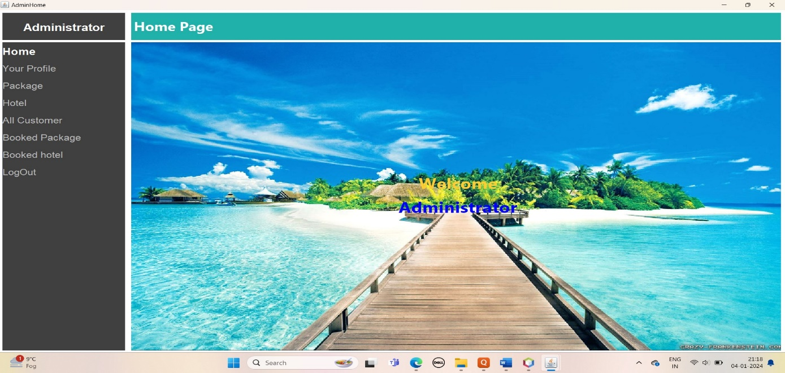

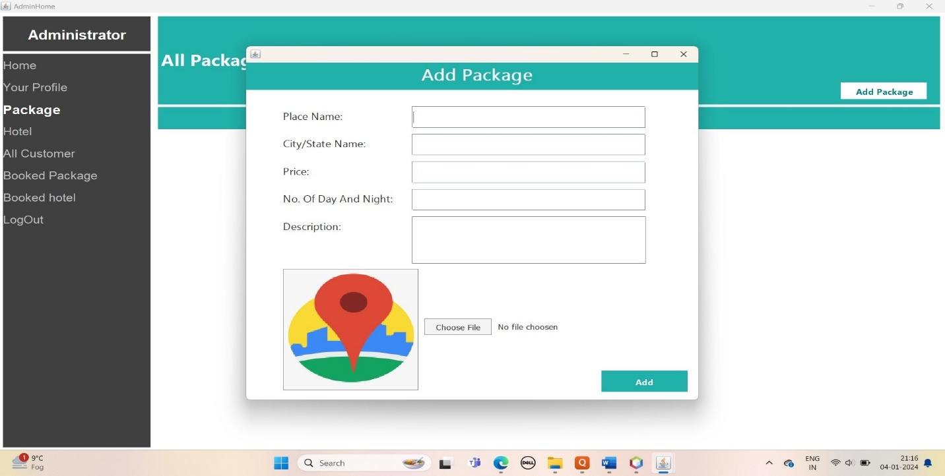

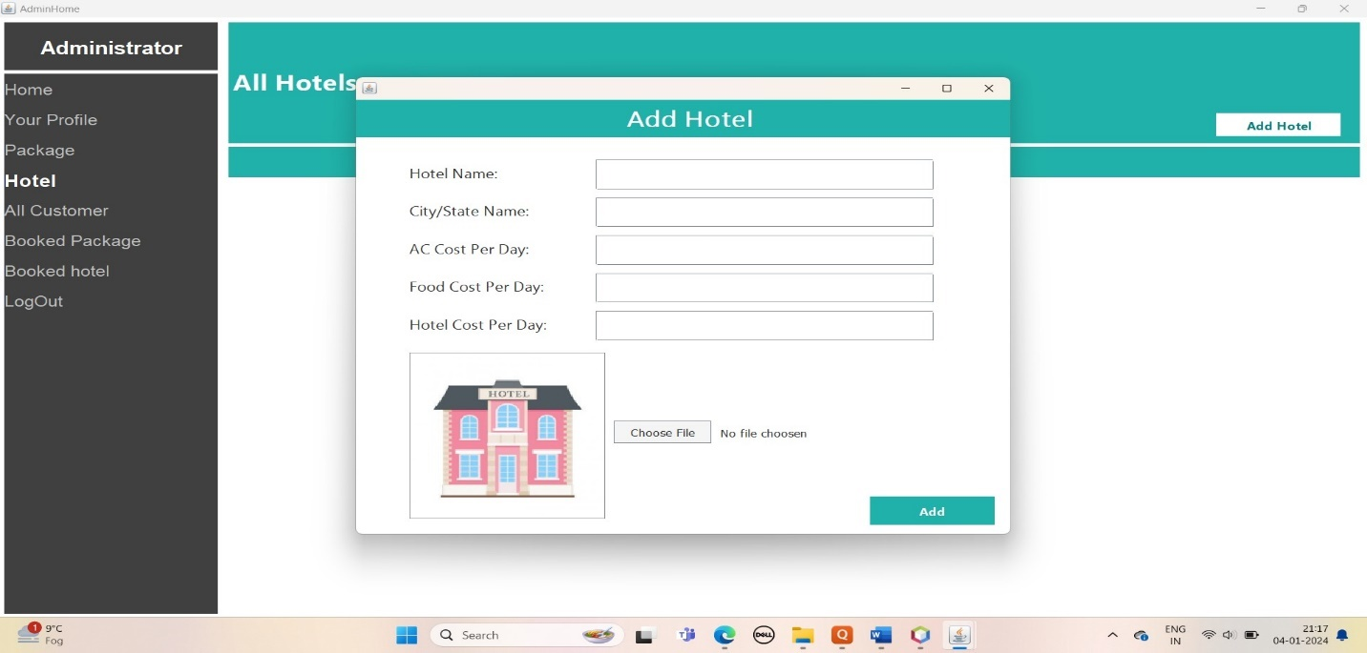

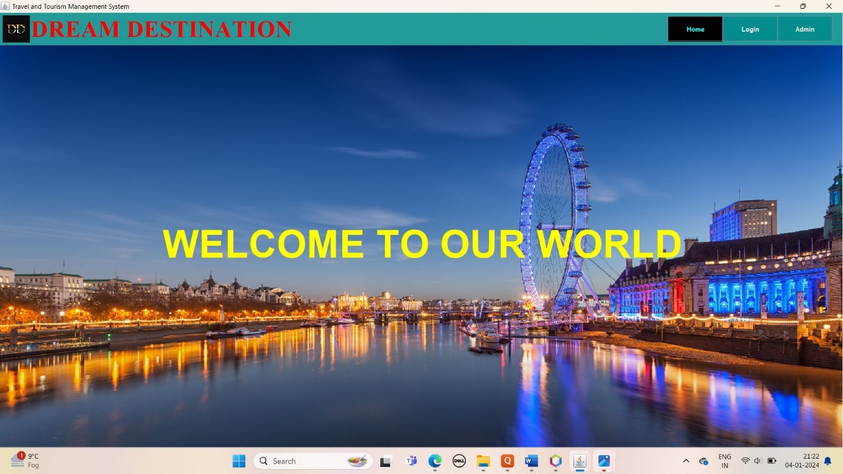

**BIBLIOGRAPHY**

1. Java Swing and AWT:
   * De Smet, M., & Walraven, B. (2005). Java Swing. O'Reilly Media.
   * Eckel, B. (2002). Thinking in Java. Prentice Hall.
   * Robinson, C. (2002). Java Swing, 2nd Edition. O'Reilly Media.
2. MySQL Database:
   * Dubois, P. (2000). MySQL. New Riders.
   * DuBois, P. (2008). MySQL Cookbook. O'Reilly Media.
   * Forta, B. (2012). MySQL Crash Course. Addison-Wesley.
3. NetBeans IDE:
   * Heffelfinger, D. (2009). Java EE 5 Development with NetBeans 6. Packt Publishing.
   * Sharan, S. (2010). JavaFX Rich Client Programming on the NetBeans Platform. Apress.
4. Project Management and Documentation:
   * Ambler, S. W. (2004). Introduction to UML 2 Class Diagrams. IBM Developer. https://www.ibm.com/developerworks/rational/library/content/03July/1000/1251/1251_ClassDiagram1.pdf
   * Gamma, E., Helm, R., Johnson, R., & Vlissides, J. (1994). Design Patterns: Elements of Reusable Object-Oriented Software. Addison-Wesley.
5. GUI Design and Usability:
   * Cooper, A., Reimann, R., & Cronin, D. (2007). About Face 3: The Essentials of Interaction Design. Wiley.
   * Nielsen, J. (1994). Usability Engineering. Morgan Kaufmann.
6. Java Database Connectivity (JDBC):
   * Keith, M., & Schincariol, D. (2007). Pro Java Database Programming. Apress.
   * Goff, J. (2002). JDBC Pocket Reference. O'Reilly Media.
7. Security in Java Applications:
   * McGraw, G. (2006). Software Security: Building Security In. Addison-Wesley.
   * Liang, S. (2005). The Java™ Tutorial: A Short Course on the Basics, 4th Edition. Pearson.
8. Testing in Java:
   * Beck, K. (2003). Test-Driven Development: By Example. Addison-Wesley.
   * Freeman, S., & Pryce, N. (2009). Growing Object-Oriented Software, Guided by Tests. Addison-Wesley.
9. Version Control with NetBeans:
   * NetBeans. (2022). Versioning and Configuration Management.

https://netbeans.apache.org/kb/docs/ide/versioning.html

1. Web Development with Java:
   * Horstmann, C., & Cornell, G. (2008). Core JavaServer Faces. Prentice Hall.
   * Cuff, D., & Lemay, L. (2009). JavaServer Faces 2.0: The Complete Reference. McGraw-Hill Education.